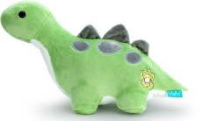  Draw your favorite toy from home. | Try and draw something you see out your window! | Draw a picture of your family. | 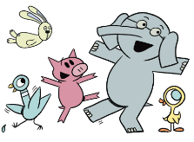  Try to draw a character from a book. | Create a comic. Show a beginning, middle, and end!
Draw outside if it is nice out / If it is cold outside draw under a blanket with a flashlight. | If you have playdough you can make a sculpture. | Draw your favorites…  Food, number, show, game, people, whatever you can thing of! | Try and draw a new animal… by putting 2 animals together. Like a bunny and a turtle! | 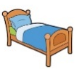  Draw a picture of your bed room like Vincent Van Gogh!
Try and draw the front of a cereal box or something out of the pantry. | Listen to music while you free draw! | 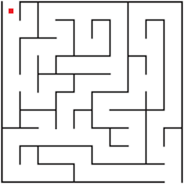  Create a maze for someone to solve. | Draw a picture of your house. | Draw outside with chalk  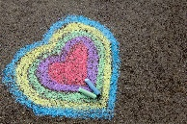
Draw a picture of your favorite holiday. | Draw a picture of your favorite time of year. | 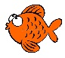  Draw a picture of the ocean. | Draw a picture of yourself. | 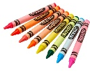  Free Draw Day!
Go on a rainbow hunt and find one thing for each color of the rainbow! Red, orange, yellow, green blue, and violet | Make a secret picture! Draw with white crayon and then color over it with marker to show your drawing! | You can do texture rubbings by taking a piece of paper and putting it on top of something like a coin, leaf, or any rough surface. Then taking a crayon and rub over the top. | Try mixing different colors of crayon to see what happens. Example:  Yellow and blue, blue and red, yellow and red, white and red… | Draw a picture and then write a sentence to go with it.
Invent your own… | 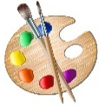  Paint at home! | Free  Square | Create a robot using all shapes. | 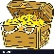  Create a treasure map!

